(Fungi) ***Clouded Funnel Cap*** *(1)*

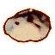

* *Replenish*
* *Fortify Magicka*

(Flora) ***Lavender Sprig*** *(1)*

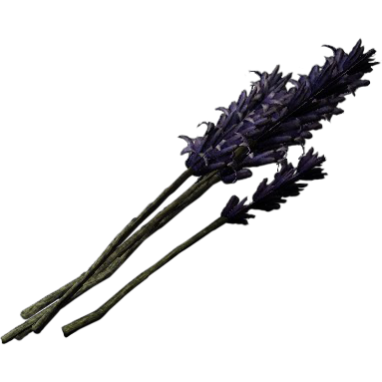

* *Fortify Stamina*
* *Heal*

(Flora) ***Milk Thistle Seeds*** *(1)*

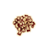

* *Light*
* *Cure Poison*

(Flora) ***Motherwort Sprig*** *(1)*

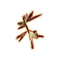

* *Silence*
* *Invisibility*

(Fungi) ***Tinder Polypore Cap*** *(1)*

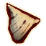

* *Replenish*
* *Invisibility*

(Flora) ***Wormwood*** *(1)*

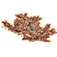

* *Respite*
* *Poison*

(Fauna) ***Mort Flesh*** *(2)*

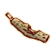

* *Poison*
* *Silence*

(Fauna) ***Troll Fat*** *(3)*

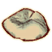

* *Heal*
* *Poison*

(Fauna) ***Minotaur Horn*** *(3)*

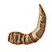

* *Slow*
* *Fortify Health*

(Fauna) ***Vampire Dust*** *(3)*

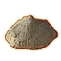

* *Invisibility*
* *Silence*

(Fauna) ***Bonemeal*** *(1)*

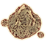

* *Night Eye*
* *Poison*

(Fauna) ***Ogre’s Teeth*** *(2)*

**

* *Empower*
* *Shock*

(Fauna) ***Daedra Heart*** *(4)*

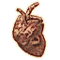

* *Heal*
* *Ward*

(type) ***Void Salt*** *(4)*

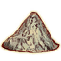

* *Shock*
* *Replenish*

(Fauna) ***Fire Salt*** *(4)*

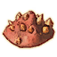

* *Flame*
* *Respite*

(Fauna) ***Frost Salt*** *(4)*

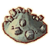

* *Frost*
* *Silence*

(Fauna) ***Daedra Venin*** *(4)*

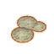

* *Paralyze*
* *Poison*

(Fauna) ***Daedroth Teeth*** *(4)*

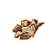

* *Night Eye*
* *Light*

(Fungi) ***Bleeding Crown*** *(1)*

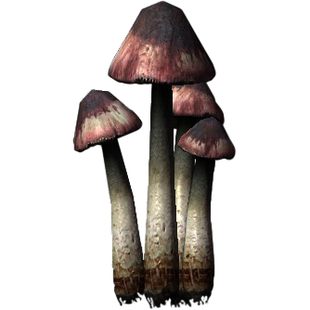

* *Weakness*
* *Ward*

(Fungi) ***Blisterwort*** *(1)*

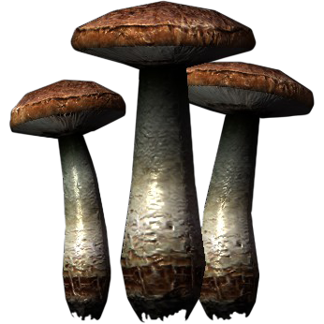

* *Fear*
* *Heal*

(Flora) ***Blue Mountain Flower*** *(1)*

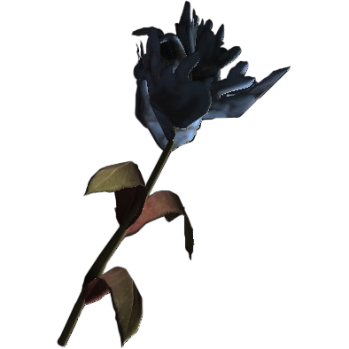

* *Heal*
* *Fortify Health*

(Fauna) ***Briar Heart*** *(3)*

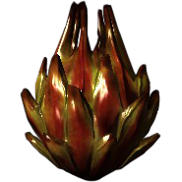

* *Replenish*
* *Ward*

(Flora)  ***Canis Root*** *(2)*

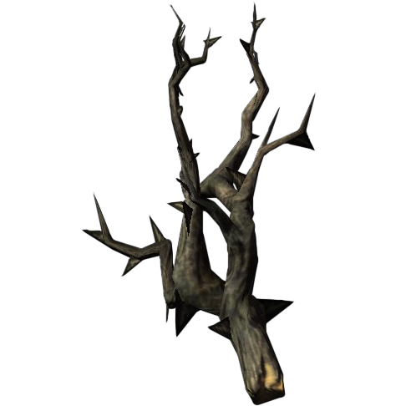

* *Poison*
* *Paralyze*

(Fauna) ***Chaurus Eggs*** *(2)*

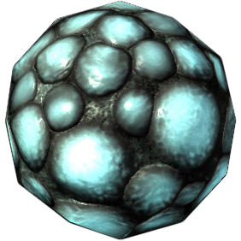

* *Respite*
* *Invisibility*

(Flora) ***Creep Cluster*** *(1)*

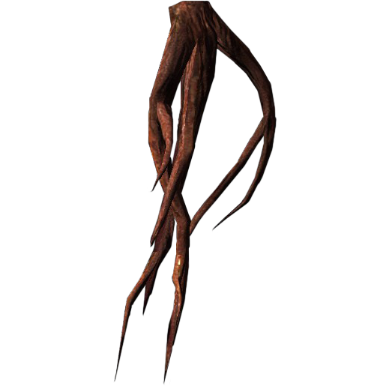

* *Replenish*
* *Empower*

(Flora) ***Nirnroot*** *(2)*

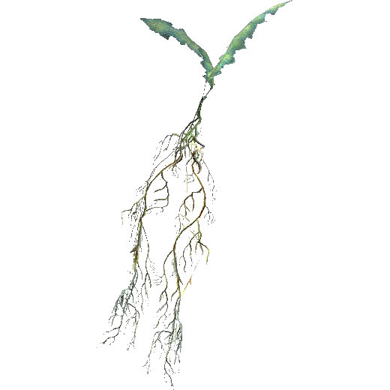

* *Poison*
* *Invisibility*

(Flora) ***Crimson Nirnroot*** *(3)*

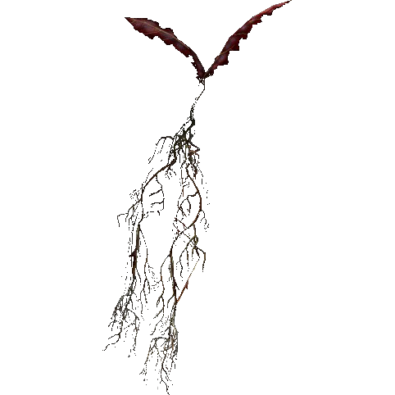

* *Poison*
* *Invisibility*

(Flora) ***Deathbell Flower*** *(1)*

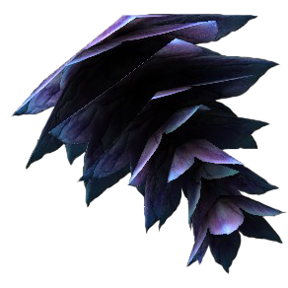

* *Poison*

(Fauna) ***Ectoplasm*** *(2)*

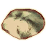

* *Replenish*
* *Dispel*

(Fungi) ***Fly Amanita*** *(1)*

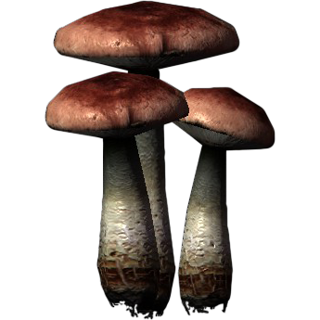

* *Fear*
* *Respite*

(Fauna) ***Sabre Cat Eye*** *(2)*

**

* *Respite*
* *Heal*

(Flora) ***Garlic*** *(1)*

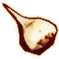

* *Cure Disease*
* *Replenish*

(Flora) ***Gleamblossom*** *(2)*

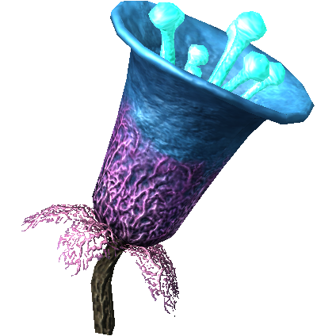

* *Fear*
* *Ward*

(Fauna) ***Glow Dust*** *(3)*

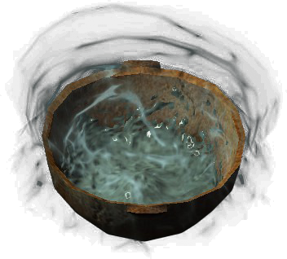

* *Light*
* *Poison*

(Fungi) ***Glowing Mushroom*** *(1)*

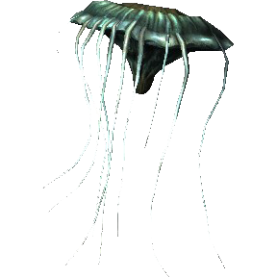

* *Fortify Health*
* *Ward*

(Fauna) ***Ice Wraith Teeth*** *(2)*

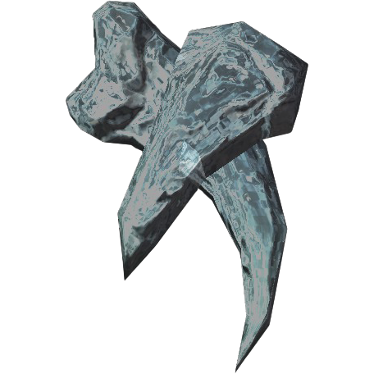

* *Weakness*
* *Invisibility*

(Fungi) ***Imp Stool*** *(1)*

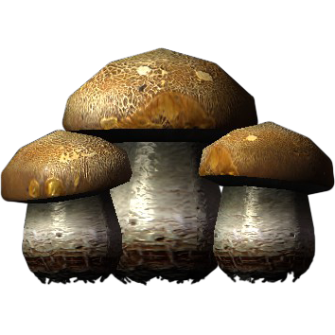

* *Poison*
* *Heal*

(Flora) ***Moon Sugar*** *(2)*

**

* *Swiftness*
* *Replenish*

(Fungi) ***Mora Tapinella*** *(2)*

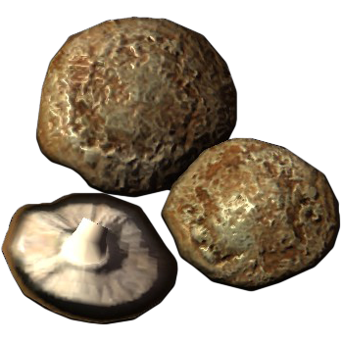

* *Replenish*
* *Respite*

(Flora) ***Nightshade*** *(2)*

**

* *Poison*
* *Silence*

(Fungi) ***Namira’s Rot*** *(2)*

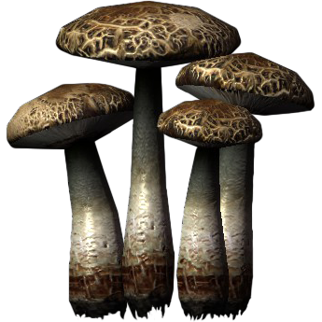

* *Fear*
* *Poison*

(Flora) ***Poison Bloom*** *(2)*

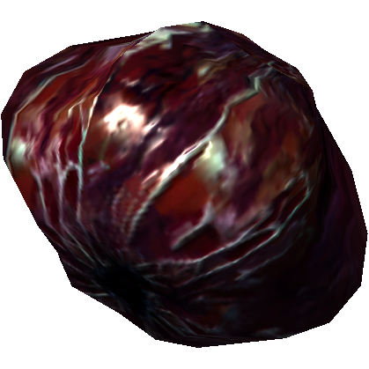

* *Poison*
* *Fear*

(Flora) ***Purple Mountain Flower*** *(1)*

**

* *Respite*
* *Ward*

(Flora) ***Red Mountain Flower*** *(1)*

**

* *Replenish*
* *Poison*

(Flora) ***Scathecraw*** *(1)*

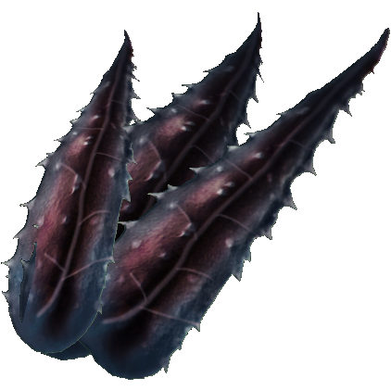

* *Poison*
* *Shock*

(Flora) ***Snowberries*** *(1)*

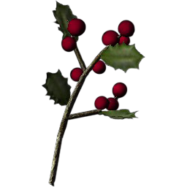

* *Ward*
* *Frost*

(Fauna) ***Spriggan Sap*** *(3)*

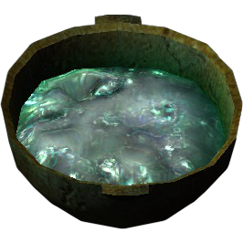

* *Fortify Magicka*
* *Respite*

(Fungi) ***Fungal Swamp Pods*** *(1)*

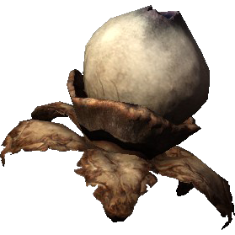

* *Paralyze*
* *Heal*

(Fauna) ***Taproot*** *(3)*

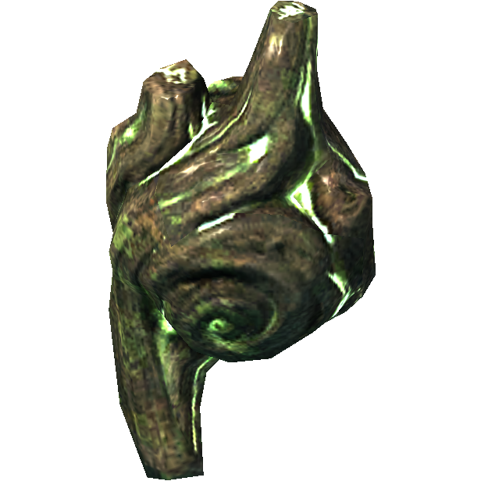

* *Replenish*
* *Ward*

(Fungi) ***White Cap*** *(1)*

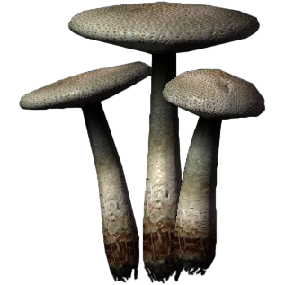

* *Weakness*
* *Replenish*

(Flora) ***Jarrin Root*** *(10)*

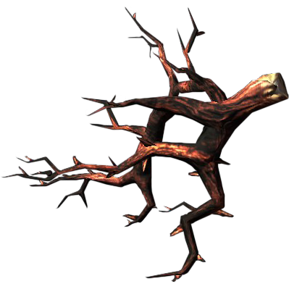

* *Poison*
* *Flame*

(Flora) ***Aloe Vera*** *(1)*

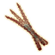

* *Respite*
* *Heal*

(Fungi) ***Bog Beacon Asco Cap*** *(1)*

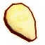

* *Replenish*
* *Ward*

(Flora) ***Lady’s Mantle Leaves*** *(1)*

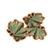

* *Heal*
* *Ward*

(Flora) ***Flax Seed*** *(1)*

**

* *Ward*
* *Replenish*

(Flora) ***Somnalius Frond*** *(1)*

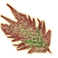

* *Feather*
* *Fortify Health*

(Flora) ***Dragon’s Breath*** *(1)*

**

* *Ward*
* *Heal*

(Flora) ***Alkanet Flower*** *(1)*

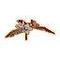

* *Cure Poison*
* *Light*

(Flora) ***Bergamot Seeds*** *(1)*

**

* *Dispel*
* *Silence*

(Flora) ***Bloodgrass*** *(3)*

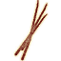

* *Cure Disease*
* *Heal*

(Fungi) ***Cairn Bolete Cap*** *(1)*

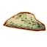

* *Heal*
* *Shock*

(Fungi) ***Cinnabar Polypore Red Cap*** *(1)*

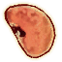

* *Respite*
* *Ward*

(Fungi) ***Cinnabar Polypore Yellow Cap*** *(1)*

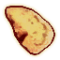

* *Respite*
* *Ward*

(Fauna) ***Clannfear Claws*** *(4)*

**

* *Cure Disease*
* *Paralyze*

(Fauna) ***Dreugh Wax*** *(3)*

**

* *Poison*
* *Buoyancy*

(Fungi) ***Dryad Saddle Polypore Cap*** *(1)*

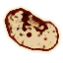

* *Cure Poison*
* *Frost*

(Fungi) ***Elf Cup Cap*** *(1)*

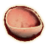

* *Cure Disease*
* *Empower*

(Fungi) ***Emetic Russula Cap*** *(1)*

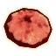

* *Poison*
* *Ward*

(Flora) ***Fennel Seeds*** *(1)*

**

* *Respite*
* *Paralyze*

(Flora) ***Foxglove Nectar*** *(2)*

**

* *Cure Poison*
* *Cure Disease*

(Flora) ***Ginkgo Leaf*** *(1)*

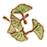

* *Replenish*
* *Shock*

(Flora) ***Ginseng*** *(1)*

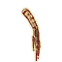

* *Cure Poison*
* *Replenish*

(Fungi) ***Green Stain Cap*** *(1)*

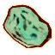

* *Respite*
* *Poison*

(Fungi) ***Green Stain Shelf Cap*** *(2)*

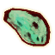

* *Poison*
* *Heal*

(Flora) ***Harrada*** *(4)*

**

* *Silence*
* *Paralyze*

(Fauna) ***Imp Gall*** *(2)*

**

* *Cure Poison*
* *Flame*

(Flora) ***Mandrake Root*** *(2)*

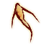

* *Cure Disease*
* *Cure Poison*

(Flora) ***Primrose Leaves*** *(1)*

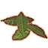

* *Cure Poison*
* *Weakness*

(Flora) ***Sacred Lotus Seeds*** *(1)*

**

* *Dispel*
* *Poison*

(Flora) ***Spiddal Stick*** *(4)*

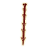

* *Flame*
* *Respite*

(Fungi)  ***Steel-Blue Entoloma Cap*** *(1)*

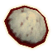

* *Replenish*
* *Flame*

(Fungi) ***Stinkhorn Cap*** *(1)*

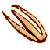

* *Buoyancy*
* *Invisibility*

(Flore) *Viper’s Bugloss Leaves (1)*

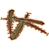

* *Night Eye*
* *Slow*

(Flora) ***White Seed Pod*** *(1)*

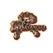

* *Buoyancy*
* *Silence*

(type) ***name*** *(R)*

**

* *G*
* *L*